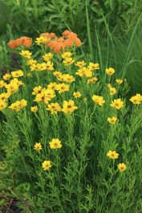
Lance Leaf Coreopsis . Coreopsis lanceolata

*1ft-2ft tall *drought tolerant
*Attracts a large number of native bees *Produces an abundance of seeds birds love
*Excellent dye plant providing a strong orange to yellow color

